Lab Manual 5

Part A – Aggregate Functions

SQL

SELECT COUNT(*) AS Total_Students FROM Student;

OUTPUT



SQL

SELECT AVG(Marks) AS Average_Marks FROM Student;

OUTPUT



SQL

SELECT MAX(Marks) AS Max_Marks, MIN(Marks) AS Min_Marks FROM Student;

OUTPUT



SQL

SELECT SUM(Marks) AS Total_Marks FROM Student;

OUTPUT

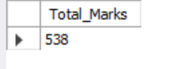

Part B – GROUP BY Clause

SQL

SELECT Department, COUNT(*) AS Student_Count
FROM Student
GROUP BY Department;

OUTPUT

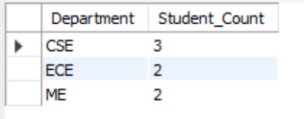

SQL

SELECT Department, AVG(Marks) AS Avg_Marks
FROM Student
GROUP BY Department;

OUTPUT
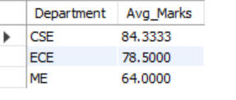

SQL

SELECT Department, MAX(Marks) AS Max_Marks
FROM Student
GROUP BY Department;

OUTPUT

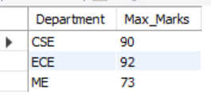

Part C – HAVING Clause

SQL

SELECT Department, AVG(Marks) AS Avg_Marks
FROM Student
GROUP BY Department
HAVING AVG(Marks) > 70;

OUTPUT

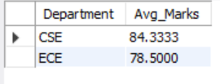

SQL

SELECT Department, COUNT(*) AS Student_Count
FROM Student
GROUP BY Department
HAVING COUNT(*) > 2;

OUTPUT

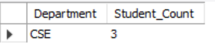

SQL

SELECT Department, MAX(Marks) AS Max_Marks
FROM Student
GROUP BY Department
HAVING MAX(Marks) > 90;

OUTPUT



Part D – Combined Queries

SQL

SELECT Department, SUM(Marks) AS Total_Marks
FROM Student
GROUP BY Department
HAVING SUM(Marks) > 200;

OUTPUT

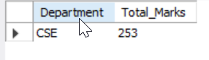

SQL

SELECT Department, AVG(Marks) AS Avg_Marks
FROM Student
GROUP BY Department
HAVING AVG(Marks) BETWEEN 60 AND 80;

OUTPUT

